Meme Analysis
Name
Institutions
Date

Meme Analysis
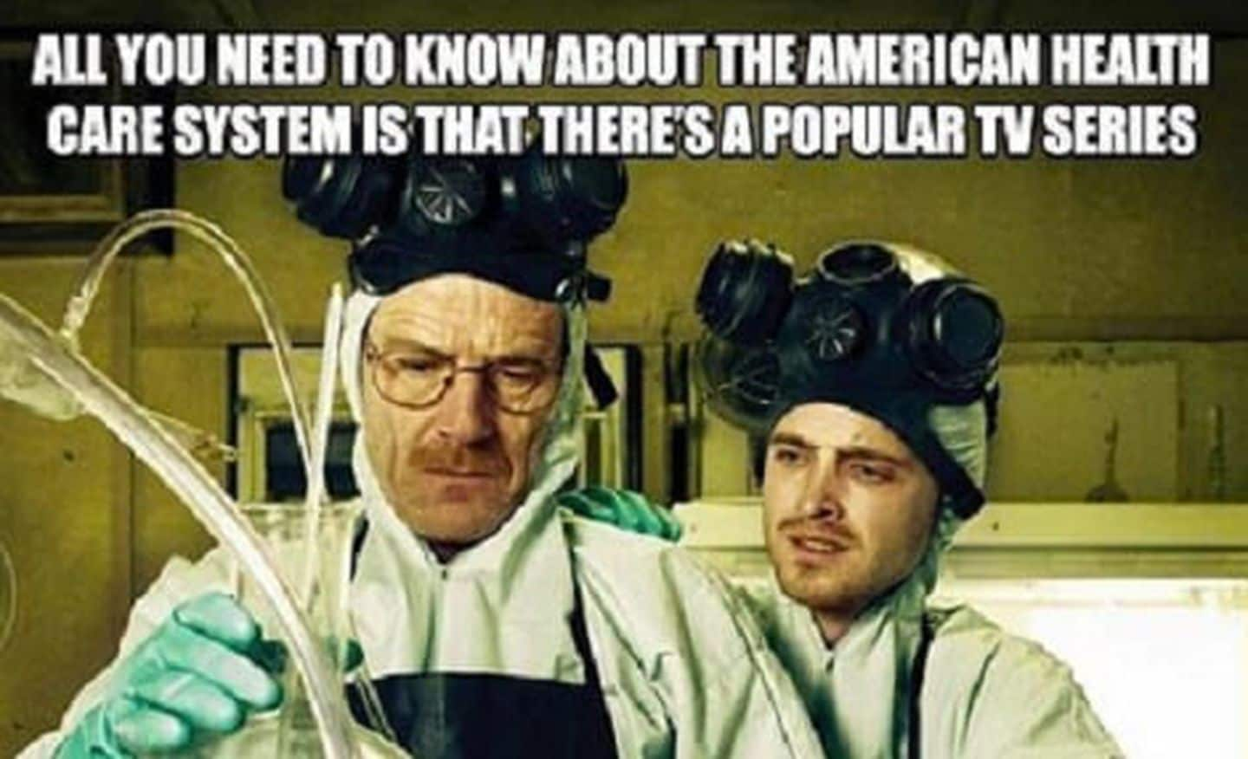

The discussion is mainly concerned about the analysis of a meme used to criticize the health care system in the United States and America. The states that, "All you need to know about the American healthcare system is that there is a popular TV series."
The statement provided in the meme brings forth an illustration that the American Healthcare System has, in the recent past, not been heading in the right direction. Additionally, the creator aimed at addressing other serious shortcomings facing the system, including work overload, paltry salary, and lack of advancement opportunities. The meme's creator aimed at responding to the claims of healthcare workers that the current healthcare system does not promote career and skill development. Again, the creator was with a view of airing health worker's claim of working too much, yet they are underpaid.

The words branded on the meme are disagreeing with the functioning of the current healthcare system in the U.S. Precisely; it suggests that that the measures which have been put in place to address critical health care conditions seem not to be effective. Again, the meme is reflecting the accurate picture of the U.S healthcare system because a survey which was conducted by CareerBuilder confirmed that more than 50 percent of U.S health care do not benefit from career programs (Hospital Review, 2020). The survey further enlightens that more than 60% of clinicians raise complaints regarding deteriorated salaries and benefits.
The aspect which is motivating the piece’s argument is the dramatic increase in the number of Covid-19 infections and resulting deaths in the U.S. By now, the U.S has recorded over 400,000 cases of Covid-19, with at least 14,000 deaths (Hyun, 2020). The meme’s creator was much disturbed by the above issue, and he addresses the healthcare administrators to put in place more comprehensive measures to contain pandemics.

References
Hyun, J.,(2020). American innovative challenge: Embracing other cultures value to fight
Covid-19. Retrieved from https://www.fastcompany.com/90485082/american-innovation-challenge-embracing-other-cultures-values-to-fight-covid-19
Hospital Review (2020). Challenges facing healthcare workers in the U.S. Retrieved from
https://www.beckershospitalreview.com/hospital-management-administration/the-top-10-challenges-facing-healthcare-workers.html

